
Activity 3.2.2 Loads

Introduction
Once an architectural program has been devised and a preliminary structural system has been chosen, the structural engineer may begin the process to design the structural elements. This requires that the engineer identify the design loads for each structural element. Once the applied design loads have been determined, the loads must be traced through the structure so that the load(s) are included in the design of each element through which the load(s) will travel.

In this activity you will determine design loads for the roof of a high school in a suburb of Chicago, Illinois (enrollment 2500) and select appropriate roof joists (beams) based on the loads transferred to the joists.

ROOF PLAN

Equipment
- Engineering notebook
- Pencil
- Calculator
- IBC Figure 1608.2 Ground Snow Loads for the United States
- Roof Deck Span-Load Table
- IBC Table 1604.5 Occupancy Category Table
- Importance Factor Table
- IBC Table 1607.1 Minimum Live Loads
- Weight of Materials Table
- K-series Standard ASD Load Table for Open Web Steel Joists
- Keystone Library Renovation Preliminary (student version).rvt

Procedure
You will calculate the design loads for the roof and choose a steel roof deck to carry the loads. You will then chase the loads to the roof beams (joists). Based on the uniform beam loading, you will then choose an open web steel joist that can carry the applied beam loading.

Criteria
- The low-slope roof will be constructed of a steel roof deck, five inches of rigid insulation, and a built-up roof (BUR).
- Assume a double span (based on cost comparison for this project) for the roof deck. Note that a double span simply means that the deck is cut so that it continuously spans from one beam, over the top of a second, and ends at the third support beam (see ROOF PLAN).
- The roof will support a mineral fiberboard suspended ceiling.
- The roof will support mechanical, electrical, and plumbing equipment (MEP). Assume 10 psf for all of this equipment.
- The building is located in an urban environment surrounded by other buildings.

- Calculate the snow load for the low-slope (flat) roof. For this structure we will use the following coefficients.
- C_{e} = 1.0 assuming an urban or suburban area surrounded by other buildings such that the building is partially exposed to the wind.
- C_{t} = 1.0 assuming the building is heated and loses some heat through the roof.
- C_{s} = 1.0 because the roof is low-slope.
- Find the roof live loading required by the IBC.
- Estimate the dead load of the roofing system by estimating the weight of all of the roof components. Note that typically the ceiling and PEM will be supported by the roof framing (and not the roof deck), but conservatively include these loads for all roof calculations.
- Determine the total design load for the roof system.
- Select a steel roof deck (double span) to support the required loads. Note that you may specify single, double, or triples spans for the roof decking depending on the relative material and installation cost of each. Assume a double span for this particular application.
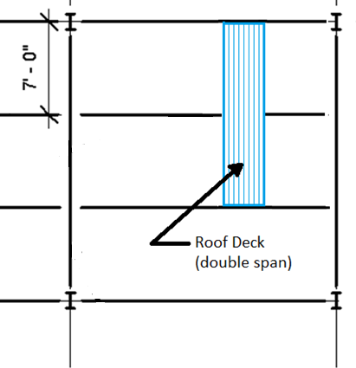
- Determine the roof beam loading for both the interior and exterior beams.
- Choose open web steel joists to act as the roof beams. For now, use only the top load values in the table and ignore the live load deflection load values. Assume the roof deck will be installed with a triple span.
- Select an appropriate Type F roof deck and open web steel joist for the Keystone Library Renovation. Show all of your work and record all of your assumptions.
- Revisit your Keystone Library Renovation 3D model and make appropriate changes to the roof system and roof framing to reflect your choices. Tag the roof joists and create a roof framing plan.

Conclusion
- Why are dead load and live load considered separately? How do they affect the structure differently?

- What is the justification for requiring engineers to consider many load combinations when designing a structure rather than just one or two?

- How would the size of the roof decking and roof beams change if the spacing of the beams was increased? Why?

